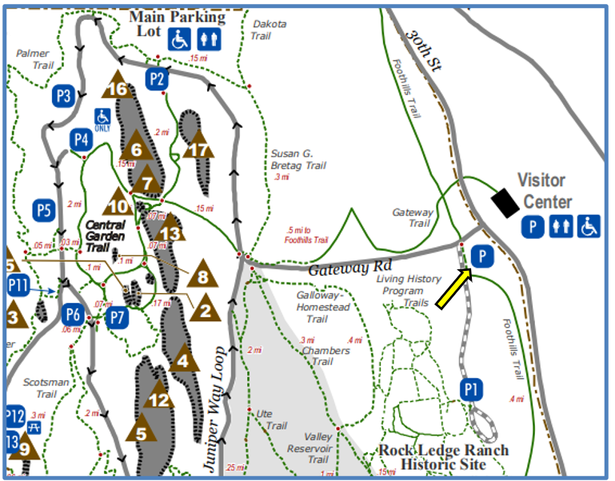
All parking is free. There are numerous parking lots throughout the park, but on busy days it may be difficult to find a space.
The Visitor and Nature Center parking lot can be quite busy. On these days, it is suggested that you use the parking lot at the entrance to the Rock Ledge Ranch (P1). This unpaved lot has a large capacity and easy walking access via a pedestrian tunnel to the Visitor and Nature Center and a flat 3/4 mile to the central garden area.
Wheelchair accessible spaces are at the Visitors Center, P2 and P4.

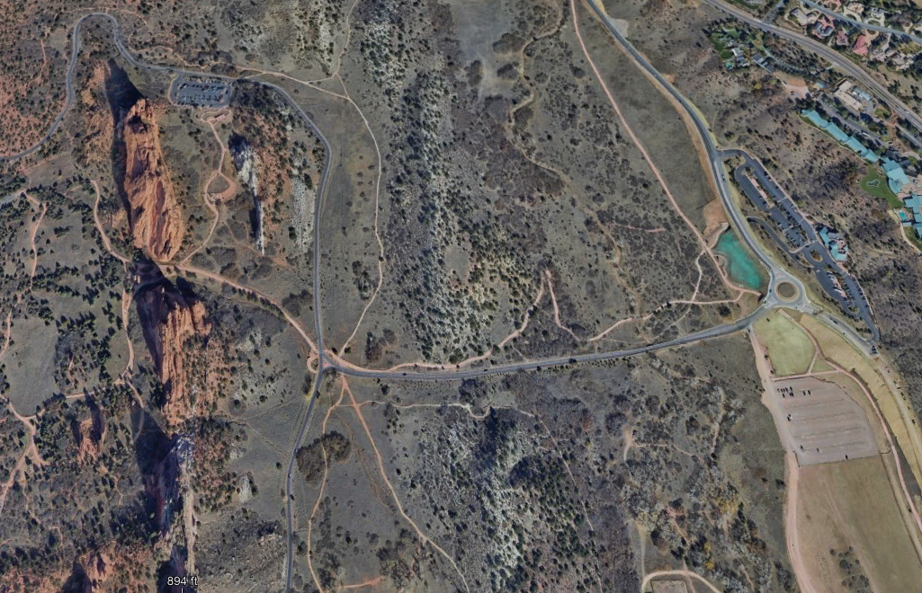
Visitor Center
Central Garden
P1
P2

